**[DFD for Online Teaching Project](https://meeraacademy.com/dfd-for-online-teaching-project/)**

Data Flow Diagram for Online Teaching Project

A data flow diagram is a graphical view of how data is processed in a system in terms of input and output.  
The Data flow diagram (DFD) contains some symbol for drawing the data flow diagram.

Context Level Diagram (0 level DFD)

The context level data flow diagram (dfd) is describe the whole system. The (o) level DFD describe all user module who operate the system. Below data flow diagram of online teaching website shows the three user can operate the system Admin, Teacher and Student.

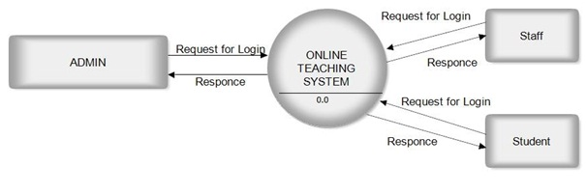

### Admin Side DFD

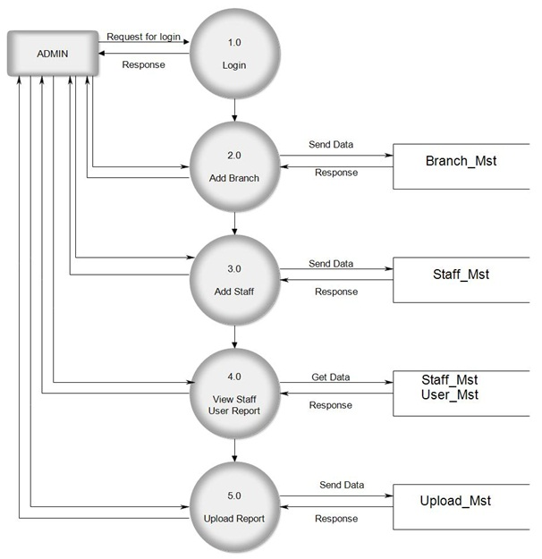

### Teacher Side DFD

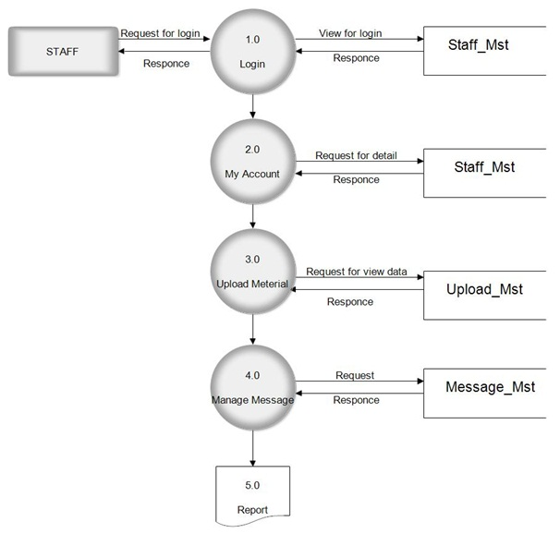

### Student Side DFD

